ACAIT – Information and Communication Technologies

Contents

OVERVIEW 1

LIST OF TOPICS 2

MOS INTRODUCE 2

MOS Level 2

MOS Version 2

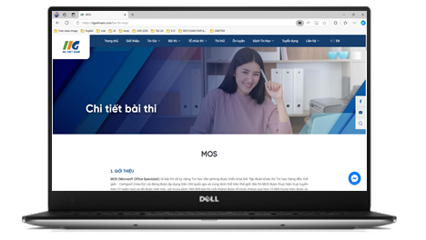Welcome to website http://www.iigvietnam.com. This website is used for sharing document, lecture, reference material without using storage device.

Moreover, students can check studying schedule, exam report, grade, etc. The website’ main contain covers lecture slides, curriculum, exercise is constructed by website owner and his colleagues.

The creators’ purpose is for studying, exchanging and sharing knowledge with positive construction not for profit.

# OVERVIEW

With the vision of sharing our knowledge of Information Technology in general and Informatic in specific, we create website ACAIT-Information Communications and Technologies to collect and rearrange educational materials and our own sources.

The website contains many literatures in different categories which have smaller groups so it is more convenience for readers. Besides, there are sections for top read articles, new articles, etc.

# LIST OF TOPICS

*The following table shows the inspection results – update Oct 2023:*

|  |  |  |  |  |
| --- | --- | --- | --- | --- |
| No. | **Categories** | **Quantity** | **Viewed** | **Responses** |
|  | Basic Informatics | 17 | 129 | 92 |
|  | Fundamental Computer | 28 | 291 | 197 |
|  | Graphic Computer | 20 | 292 | 201 |
|  | Multimedia | 32 | 392 | 231 |
|  | Web Technologies | 34 | 128 | 92 |
|  | Application Programming | 32 | 232 | 192 |
|  | Networking | 29 | 262 | 232 |
|  | Windows Mastery | 28 | 382 | 23 |
|  | Smart Phone | 19 | 408 | 231 |
|  | MOS – IC3 | 15 | 123 | 111 |

# MOS INTRODUCE

*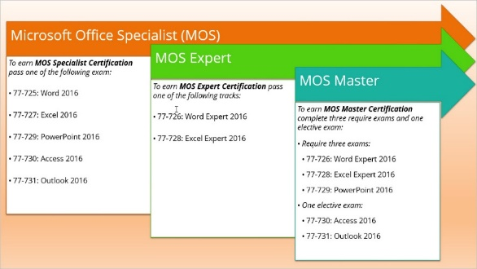MOS is an acronym for Ms Office Specialist which is the most widely used office computing skills test in the world with over 1 million tests taken annually.*

The MOS test was created by Microsoft and performed by Certiport (USA). The exam is conducted online, with more than 25 languages ​​built, including Vietnamese.

**MOS is the only justification that validates your skills in using Ms Office and is directly certified by the CEO of the Microsoft Corporation**

## MOS Level

## MOS Version

MOS 2013 (Office 2013)

MOS 2016 (Office 2016)

MOS 2019 (Office 2019)

For more information, please visit fan page: https://www.facebook.com/iigvietnam.com.

# iig viet nam



IIG Vietnam is the exclusive provider of the Microsoft Office Specialist (MOS) exam in Vietnam. This international certification assesses users' proficiency in Microsoft Office skills. As the sole authorized provider, IIG Vietnam ensures that each exam meets global standards of quality and credibility.

IIG Vietnam has established a solid reputation in delivering international certifications, especially the MOS certification. With a professional exam administration system, IIG Vietnam provides candidates with a reliable testing experience. The organization is committed to ensuring transparency, fairness, and high-quality standards in every MOS exam.

Obtaining a MOS certification from IIG Vietnam enhances learners' skills and boosts their competitiveness in the job market. This certification is highly valued by employers, allowing candidates to showcase their Microsoft Office expertise. IIG Vietnam provides a comprehensive testing pathway and study support to help users achieve the best results.

IIG Vietnam not only administers exams but also contributes to the growth of the IT community in the country. Through programs, events, and seminars, IIG promotes awareness of international standards in information technology. This organization plays a key role in advancing the professionalism of Vietnam’s IT workforce.